Syscomm Database (How to import the database

* First download xampp

: [https://www.apachefriends.org/xampp-files/8.0.13/xampp-windows-x64-8.0.13-0-VS16installer.exe](https://www.apachefriends.org/xampp-files/8.0.13/xampp-windows-x64-8.0.13-0-VS16-installer.exe)

* Run your xampp

: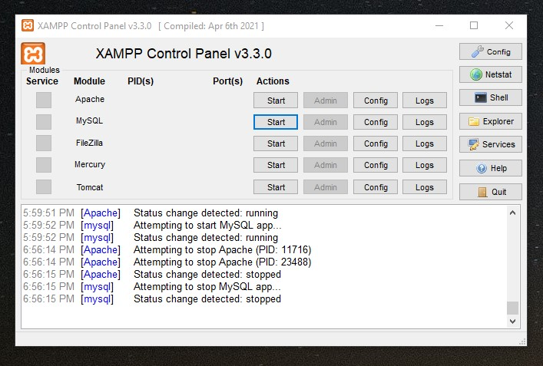

* Click start on Apache and MySQL. (The text should be highlighted in green)

: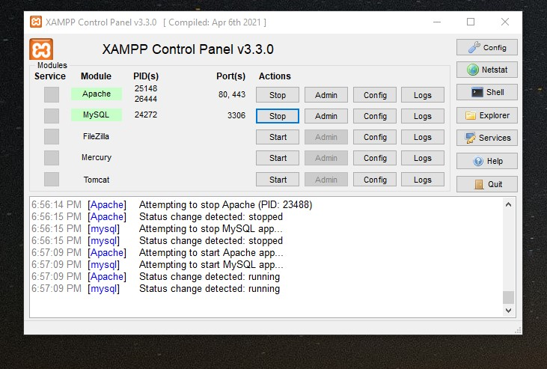

* Go to your browser and type this link

: <http://localhost/phpmyadmin/>

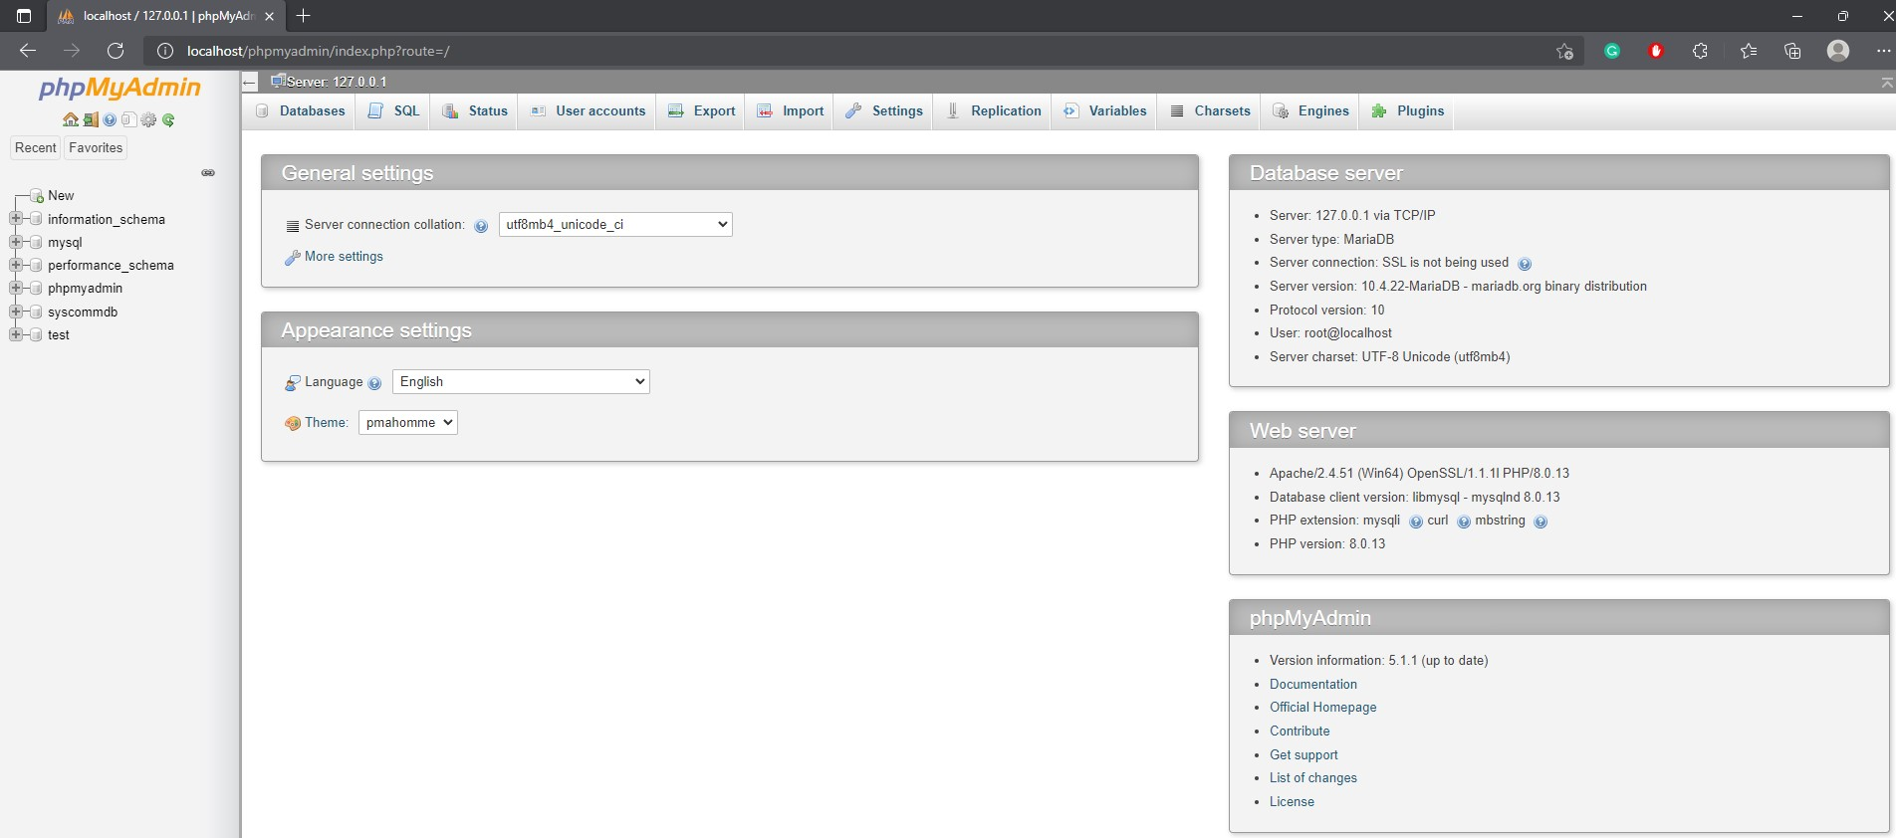

* Create a new database name “syscommdb”
* And click that database then import
* 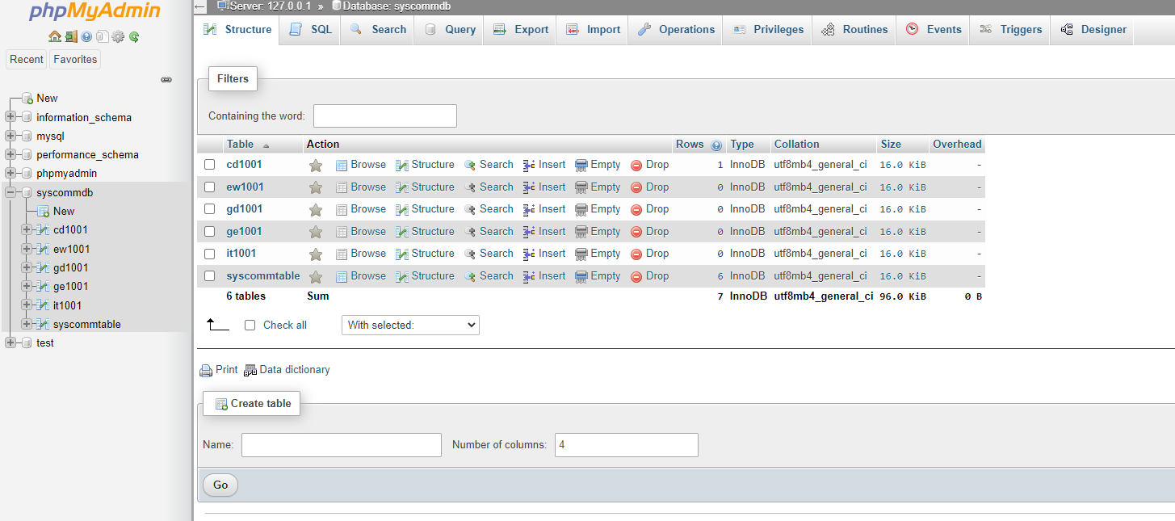
* 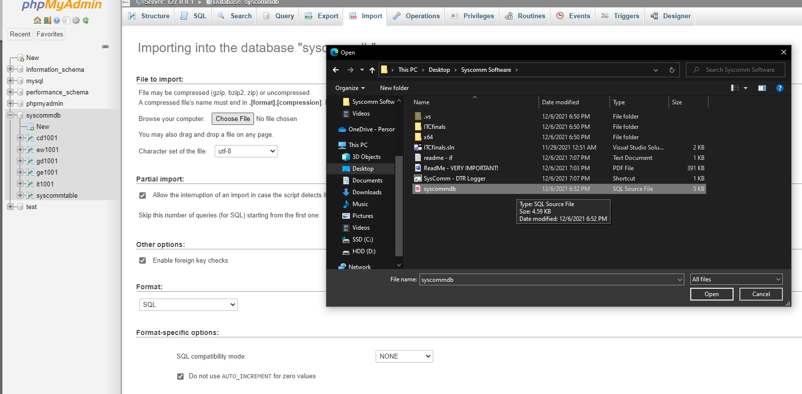
* Then click go and run the software